**PJ 3 Report Your Name: Francisco Valadez**

**A. The following is my Java program:**

**// Please copy your Java program into here from your Eclipse window. The code must be colored.**

**// You must not copy Java program from your .java file since the code over there is not colored at all.**

**// You must not show screen prints here.**

//Author: Francisco Valadez  
//Date: 5/12/2021  
//Purpose: This program solves the towers of hanoi problem by getting the number of disks  
// from a user and then uses recursion to move those disk from pole A to pole B  
  
import java.util.Scanner;  
  
public class Hanoi  
{  
 public static void main(String[] args)   
 {  
 int disks;  
  
 Scanner input = new Scanner(System.in);  
 System.out.print("Welcome to play the Towers of Hanoi Game of Francisco Valadez!\n" +   
 "1=============================================\n" +   
 ">> Please enter the number of disks for this game: ");  
 disks = input.nextInt();  
 //checks if the number is negative  
 if ((disks == 0) || (disks <= 0))  
 System.out.println("No Disks to play with.");  
 else  
 //sends to the amount to a method that will 'move' the disks to pole B  
 solution(disks, 'A', 'B', 'C');   
   
 //System.out.println((int)(Math.pow(2, disks) - 1)); //used for troubleshooting  
  
 System.out.println("2=============================================\n" +   
 "Thank you for playing the Towers of Hanoi Game of Francisco Valadez.\n" +   
 "3=============================================");  
  
 }  
  
 //Recursion method  
 static void solution(int disks, char tower1, char tower3, char tower2)  
 {  
 if (disks == 1)  
 System.out.println("Move top disk from pole " + tower1 + " to pole " + tower3);  
 else  
 {  
 //Recursion all the way down  
 solution(disks - 1 , tower1, tower2, tower3);  
 System.out.println("Move top disk from pole " + tower1 + " to pole " + tower3);  
 solution(disks - 1, tower2, tower3, tower1);  
 }  
 }  
}

**B. The following is the complete output of my 3 test cases: [You must show 3 test cases.]**

**// Please copy your Eclipse console output into here.**

**Test Case 1:**

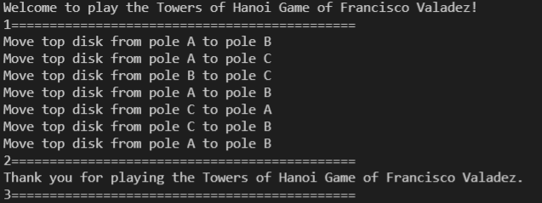

**Test Case 2:**

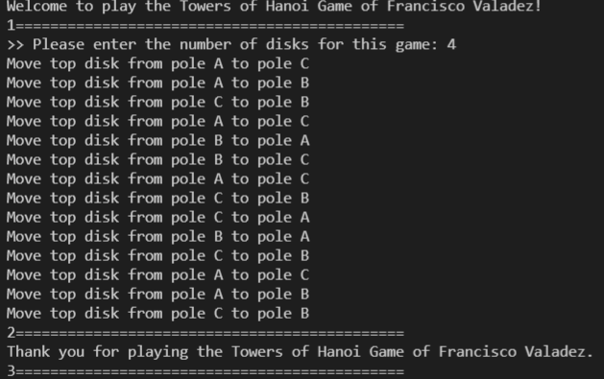

**Test Case 3:**

